Evaluation

Contents

What I set out to Create 2

What I created 2

3

Limitations 4

# What I set out to Create

I set out to create a functioning spreadsheet with protections that prevented the user editing certain fields doing so that will stop the user creating errors in the system which makes it more professional and understandable for new spreadsheet users, I made sure it contains multiple “Vlookups, Count if, And IF / And” statements.

I also added a macro that can Add, Edit and remove users to the spreadsheet again by doing so it prevents errors.

## What I created

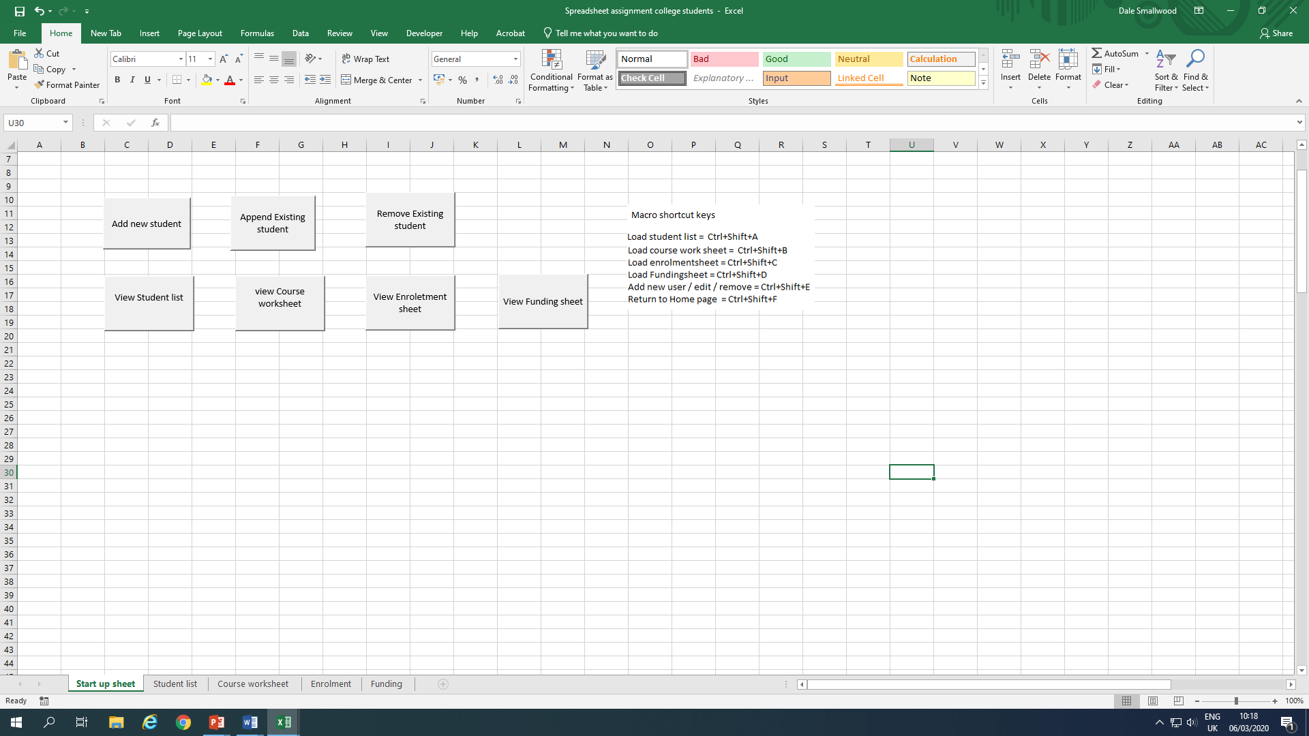

This screenshot shows a navigation menu.

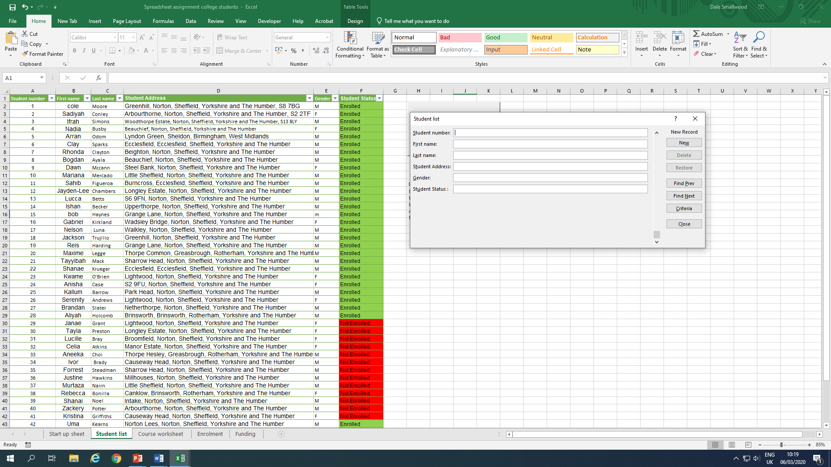

This is a screenshot of the student list with the option of adding a new student to the list.

# 

# Imitations

# 

This is a screenshot of the list of courses available, start date, end date and cost.

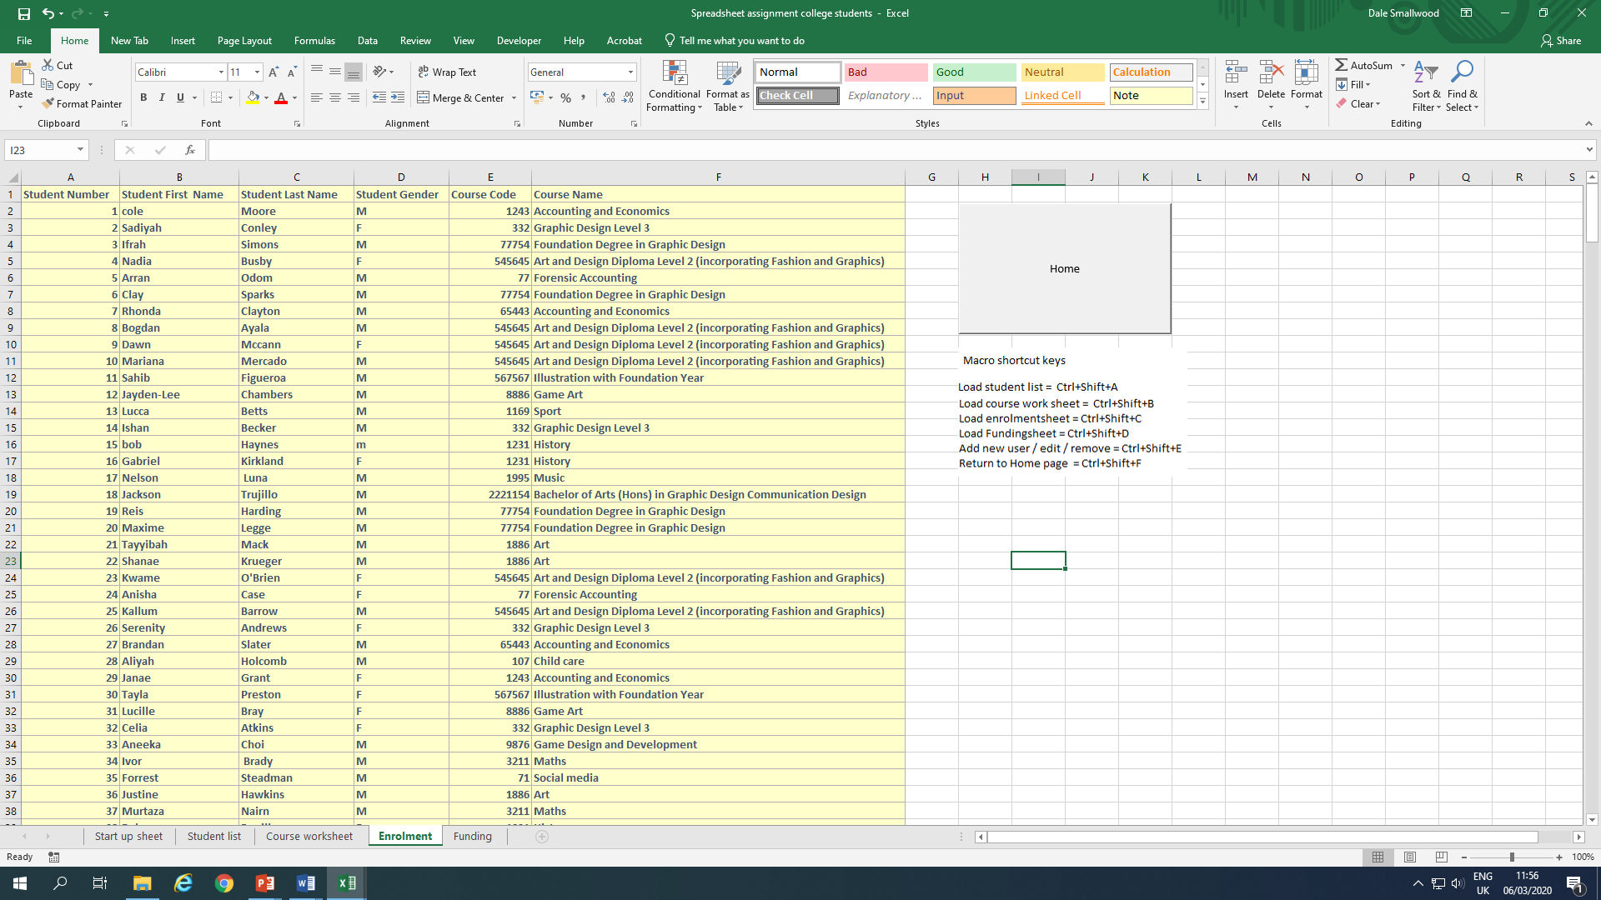

This screen shot shows information of the student, what course they are enrolled too with a drop-down feature to switch courses if needed

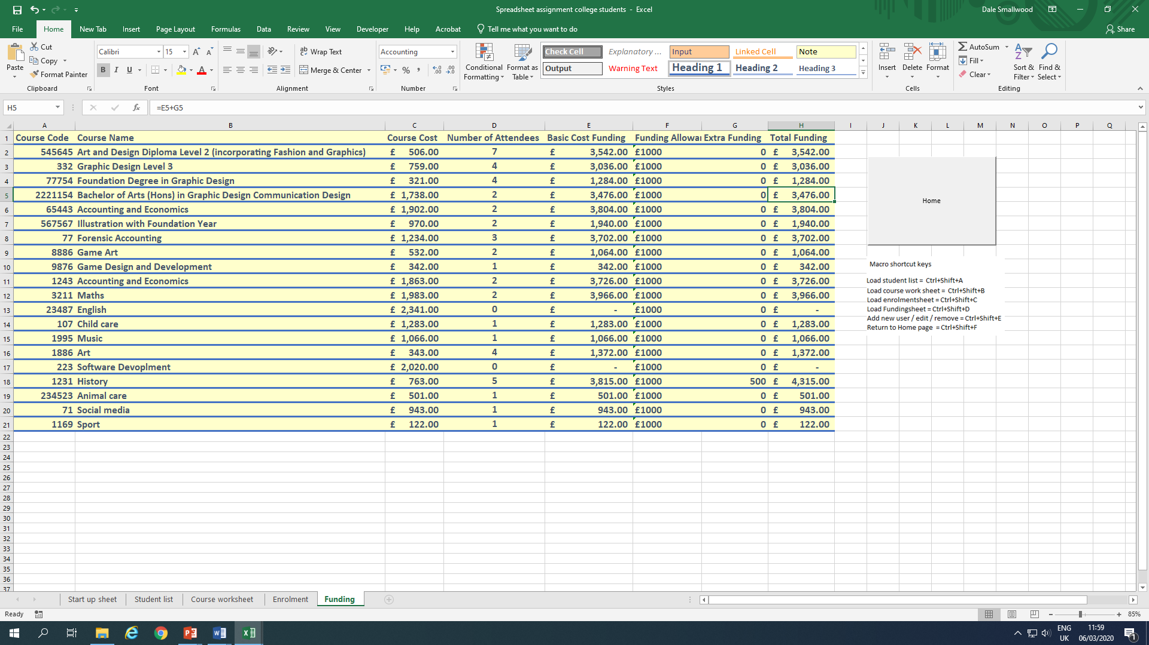

The screenshot shows the list of courses, how many has applied, total cost with a count if statement and an IF, AND statement for the extra funding.

# Limitations

While creating the spreadsheet I came across a few issues that limited my final result such as.

1. I tried adding a button that would move down a list by one but that was not possible due to the fact that the button is linked to a macro that copies your input and not act on its own.
2. I wanted to create 3 different buttons that add, edit and remove information but the macro would be identical for each one.